SOFTWARE REQUIREMENTS

SPECIFICATION

Date: 19-10-2023

Prepared by: Zainul Abideen EH

| SI | **TABLE OF CONTENTS** | Page no |
| --- | --- | --- |
|  |  |  |
| 1 | INTRODUCTION |  |
|  | 1.1-Purpose |  |
|  | 1.2-Scope |  |
|  | 1.3-Objectives |  |
| 2 | FUNCTIONAL REQUIREMENTS |  |
|  | 2.1-Primary Actors Of the system |  |
|  | 2.2-Use Case Diagram |  |
|  | 2.3-User stories |  |
|  | 2.4-Business Process Diagram |  |
| 3 | NON FUNCTIONAL REQUIREMENTS |  |
| 4 | TECHNICAL REQUIREMENTS |  |
| 5 | CONCLUSION |  |

**JOB PORTAL**

Software Requirements Specification(SRC)

Project for Java Training Boot Camp

**Introduction**

A job portal system is an online platform that connects job seekers with potential employers. Its purpose is to streamline the job search process by allowing job seekers to upload their resumes, browse job listings, and apply for positions, while employers can post job openings and search for suitable candidates. It serves as a centralised hub for job-related activities, benefiting both job seekers and employers in the recruitment process.

Clearly defining system requirements for a job portal is crucial for successful development and implementation for several reasons:

Alignment with Stakeholder Expectations: Defining requirements ensures that the portal aligns with the expectations and needs of stakeholders, including employers, job seekers, and administrators.

***Functional Scope Clarity:*** It helps in outlining the specific features and functionalities the portal must have, preventing scope creep and ensuring the development stays focused.

***Efficient Development Process:*** Well-defined requirements guide the development team in creating a structured plan and roadmap, optimising the development process for efficiency and cost-effectiveness.

***User Experience Enhancement:*** Understanding user needs helps design an intuitive user interface and experience, enhancing usability and attracting more users to the platform.

***Scalability and Flexibility:*** Requirements clarify scalability needs, allowing for the design of a system that can handle increased traffic and data as the platform grows, ensuring long-term viability.

***Integration and Interoperability:*** Clearly stated requirements aid in planning integration with other systems or platforms, ensuring seamless interactions and data sharing.

***Risk Mitigation:*** By identifying potential risks and challenges early on, clear requirements enable proactive risk management strategies, reducing the likelihood of project delays or failures.

***Quality Assurance and Testing:*** Defining requirements aids in creating comprehensive test cases, facilitating thorough testing to ensure the portal functions as intended and meets all criteria.

***Client Communication and Feedback:*** Clearly defined requirements provide a basis for ongoing client communication, feedback, and validation, ensuring that the portal meets expectations and can be adjusted as necessary.

***Regulatory Compliance:*** Requirements ensure that the portal complies with legal and industry-specific regulations, minimising legal risks and penalties.

In summary, a well-defined set of system requirements is fundamental for the successful development and implementation of a job portal, ensuring it meets the needs of stakeholders, is user-friendly, scalable, and aligned with regulatory and industry standards.

**1.1- Purpose**

The Software Requirements Specification (SRS) document for the job portal system outlines the functional and nonfunctional requirements, system behaviour, constraints, and other essential details necessary to design, develop, and test the job portal software. It serves as a blueprint for the development team, stakeholders, and testers, ensuring a clear understanding of the system's objectives and expectations.The purpose of the SRS document for the job portal system is to capture and document both the functional and non- functional requirements of the system.

This includes specifying the system's features, capabilities, constraints, and performance expectations, providing a comprehensive and structured foundation for the system's development and evaluation.

**1.2- Scope**

The scope of a job portal system typically includes the following components:

User Registration and Profile Management**:** Allow job seekers and employers to create accounts, manage their profiles, and provide relevant information such as resumes, job postings, and company profiles.

Job Search and Matching: Implement a search and matching algorithm that helps job seekers find relevant job listings based on their skills, experience, and preferences. For employers, this involves finding suitable candidates.

Job Posting and Management:Enable employers to post job openings, manage job listings, and specify job requirements, including qualifications, experience, and job descriptions.

Application and Resume Submission***:*** Allow job seekers to apply for jobs and upload their resumes. Employers should be able to review applications and resumes.

Communication Tools: Implement communication features such as messaging or email systems to facilitate interactions between job seekers and employers.

Resume Parsing: Include a feature that can extract relevant information from uploaded resumes to populate job seeker profiles or match candidates to job postings.

Notifications: Send automated notifications to users about new job postings, job matches, application status, and other relevant updates.

User Verification and Security: Ensure data security and user verification mechanisms to protect user information and the integrity of the platform.

Feedback and Rating System: Allow users to provide feedback and ratings for employers and job seekers to establish credibility and trust within the platform.

Analytics and Reporting: Provide analytics tools for administrators to track platform usage, job posting performance, and user engagement.

Mobile Accessibility: Ensure that the job portal is accessible via mobile devices, as many users access such platforms on smartphones.

Administrative Tools: Offer tools for platform administrators to manage users, monitor activity, and oversee the system's overall operation.

Payment Processing (Optional): If the platform charges fees for premium services, incorporate a secure payment processing system.

Integration with Social Media: Allow users to connect their profiles with social media accounts for easier sharing and networking.

Geographic Expansion (Optional): Consider the possibility of expanding the platform's reach to multiple geographic regions or markets.

The specific features and functionalities can vary based on the target audience and the business model of the job portal system.A job portal system incorporates several key functionalities and features to cater to both job seekers and employers:

Job Listings and Search:Allows employers to post job openings with detailed descriptions.

Enables job seekers to search for jobs based on various criteria such as location, industry, skills, and experience level.

User Registration and Profiles:Allows job seekers and employers to create accounts and maintain profiles with personal, contact, and professional information.

Resume/CV Upload and Building:Job seekers can upload existing resumes or create resumes within the portal using templates and tools provided.

Application Management:Job seekers can apply for jobs through the portal, track their application status, and withdraw applications if needed.

Employers can review applications, shortlist candidates, and manage the hiring process.

Notification and Alerts:Sends notifications to job seekers about new job postings, application status updates, and interview invitations.

Alerts employers about new applications, candidate responses, and other relevant updates.

Communication Platform:Provides a communication channel for job seekers and employers to interact, schedule interviews, and discuss job-related matters.

Interview Scheduling and Management:Allows employers to schedule and manage interviews with candidates, including setting interview times, locations, and tracking responses.

Skill and Personality Assessments:May integrate skill and personality assessments to evaluate candidates and match them with suitable job opportunities.

Analytics and Reporting:Provides employers with analytics on job postings, candidate engagement, and recruitment performance for informed decision-making.

Admin Dashboard:Enables administrators to monitor and manage the overall system, including user accounts, permissions, and system settings.

Secure Authentication and Authorization:Ensures the security and privacy of user data through robust authentication and authorization mechanisms.

Mobile Responsiveness:Ensures accessibility and functionality of the portal on various devices, including smartphones and tablets.

These functionalities collectively streamline the job search and recruitment process, making it more efficient and effective for both job seekers and employers.

Job portal systems may have limitations such as regional focus, paid services for premium features, privacy concerns, and limited industry coverage. They might lack advanced matching algorithms, comprehensive company information, and career guidance resources. Mobile accessibility, outdated listings, and limited integration options could also be drawbacks. Remote job opportunities may not be well-represented, and customer support quality can vary. It's important to choose a job portal that aligns with your specific needs and preferences.

Job Portal User Roles

In a typical job portal system, there are several user roles or types of users that the system caters to:

Job Seekers: These are individuals who are looking for employment opportunities. They create profiles, upload resumes, and search for job listings that match their skills and preferences.

Employers: Employers are organizations or companies looking to hire talent. They use the job portal to post job openings, review applicant profiles, and manage the hiring process.

Administrators: Administrators are responsible for managing and maintaining the job portal system. They oversee user accounts, ensure the platform's functionality, and handle any technical or operational issues that may arise.

These are the primary user roles, but depending on the specific job portal, there may be additional roles or features to cater to other stakeholders, such as recruiters, freelance job seekers, or industry-specific roles.

**1.3- Objectives**

Connect Job Seekers and Employers:Facilitate the connection between individuals seeking employment and organisations with job openings.Job Posting and Management: Enable employers to post job openings, manage listings, and efficiently review and communicate with applicants.Administer User Accounts: Ensure secure and well-maintained user accounts, including roles, permissions, and user support.These objectives are designed to create a robust and user-friendly job portal system that serves the needs of both job seekers and employers while ensuring data security and scalability.

The goals and problems that a job portal system aims to address typically include:

Matching Job Seekers to Suitable Positions: The system aims to help job seekers find relevant job opportunities by matching their skills, qualifications, and preferences with job listings, thereby reducing job search frustrations.

Reducing Time and Cost of Hiring: Traditional hiring processes can be time-consuming and expensive. The job portal system aims to reduce the time and cost associated with recruitment through automation and digital processes.

Improving Communication: Job seekers and employers can communicate through the platform, improving the efficiency of scheduling interviews and exchanging information.

Equal Opportunity Employment: Promoting fair and unbiased recruitment practices to ensure equal opportunity for all candidates, regardless of their background.

**FUNCTIONAL REQUIREMENTS**

Functional requirements are product features or functions that developers must implement to enable users to accomplish their tasks. So, it’s important to make them clear both for the development team and the stakeholders. Generally, functional requirements describe system behaviour under specific conditions.

**2.1- PRIMARY ACTORS OF THE SYSTEM**

* Job Seeker

This primary actor represents individuals who are actively seeking employment opportunities. Job seekers use the job portal to create profiles, search for job listings, submit applications, and manage their job-seeking activities. They are the individuals looking for job openings and are the end-users who interact with the platform to find employment.

* Job Provider

The job provider, often referred to as the employer or recruiter, is another primary actor. These entities or individuals use the job portal to post job listings, review and manage job applications, and ultimately hire candidates. They are the ones offering employment opportunities and interacting with job seekers through the platform.

* Admin

The admin is an internal actor responsible for managing and overseeing the job portal system. Administrators have various roles and responsibilities, including user account management, ensuring platform compliance, reviewing and moderating job listings, providing support to users, and generating reports and analytics. They maintain and monitor the system's functionality, making sure it operates smoothly and securely.

These primary actors play crucial roles in the functioning of the job portal system, representing the key user groups that interact with the platform. Job seekers are the individuals looking for job opportunities, job providers are the ones offering job openings, and admins are responsible for maintaining and managing the system to ensure a smooth experience for both job seekers and job providers

**2.2- USECASE DIAGRAM**

* Job seeker

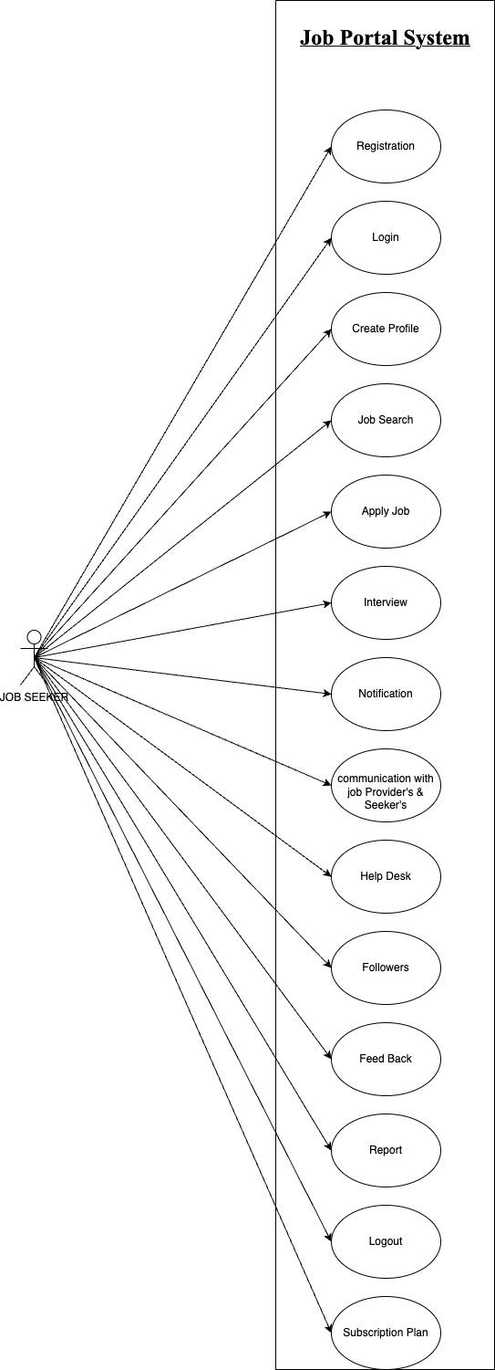

* Job Provider

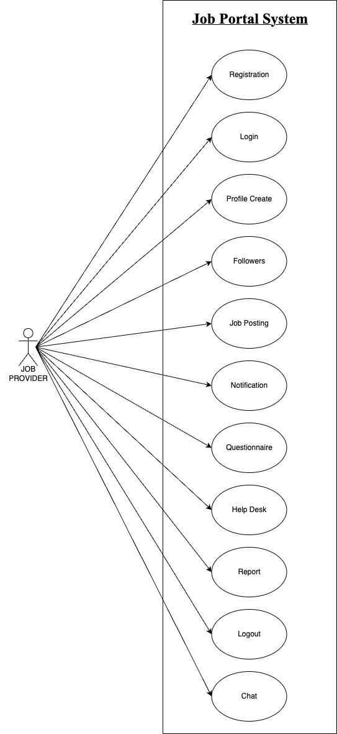

* Admin

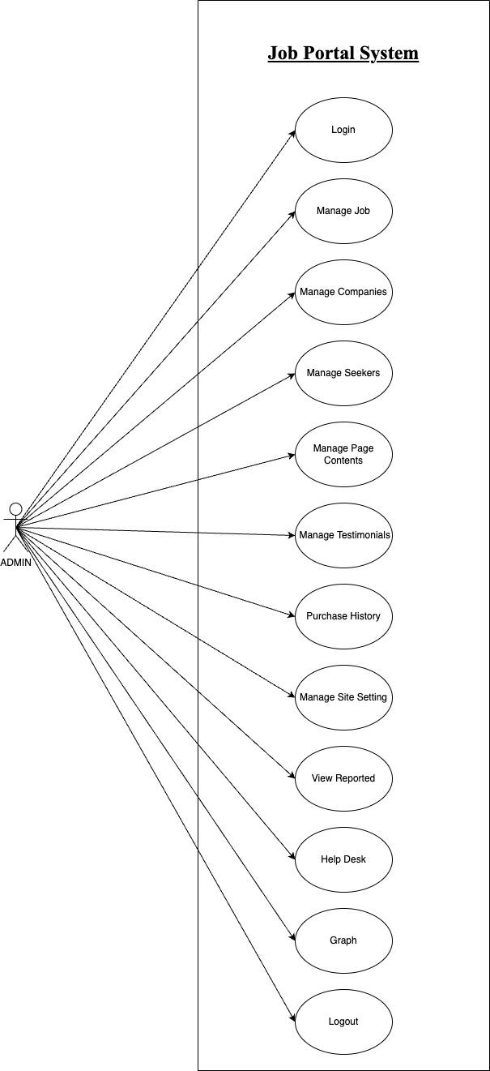

**2.2- USER STORIES**

| As A [type of user] | I NEED TO [do some task] | SO THAT I CAN [get some result] |
| --- | --- | --- |
| Job seeker | Login to the app as i registered | Enter my username & password to access my account |
| Job provider | Post a job on the job portal | Advertise job openings and attract employees |
| Platform Admin | Approve job providers before they can post job listings on the platform | Ensure the quality of job listings on the platform and prevent fake job posting |

**2.4- BUSINESS PROCESS DIAGRAM**

* Login

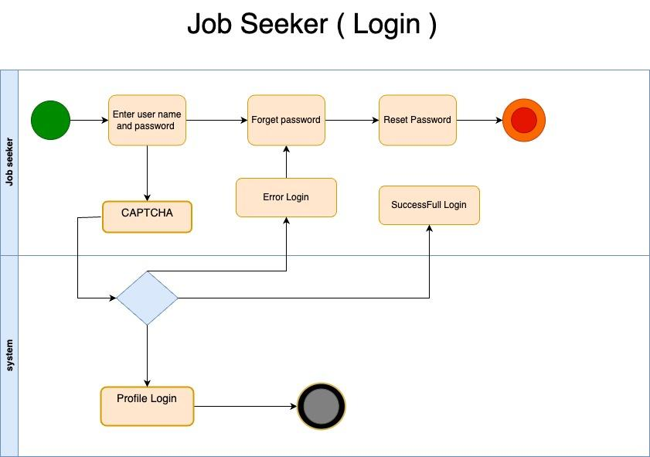

* Apply job

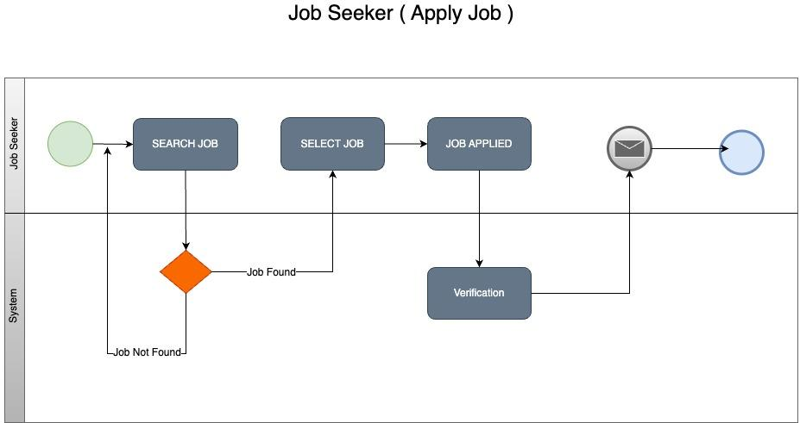

* Job posting

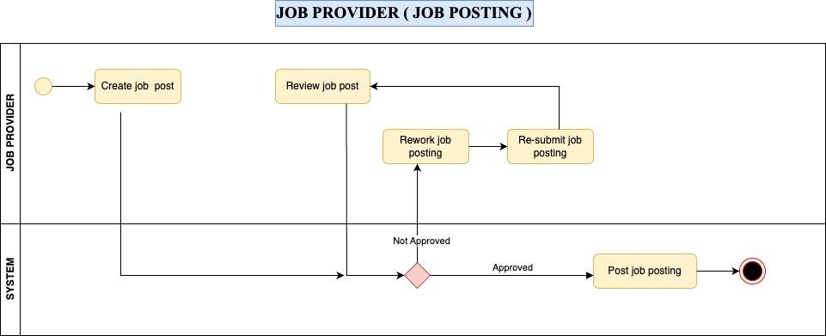

* Interview

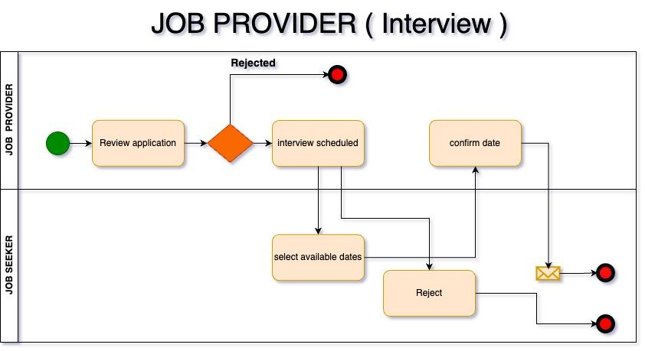

**NON FUNCTIONAL REQUIREMENTS**

* Performance

The system should have fast response times to ensure a smooth user experience.

It should be able to handle a large number of concurrent users without significant performance degradation.

* Reliability:

The system must be available 24/7, with minimal downtime for maintenance or upgrades.

It should have a backup and disaster recovery plan to ensure data integrity and availability.

* Security:

User data, including personal and payment information, must be securely stored and transmitted.

Implement strong authentication and authorization mechanisms to protect user accounts.

Guard against common security threats like SQL injection, cross-site scripting, and data breaches.

* Usability:

The user interface should be intuitive,user-friendly,and accessible to a wide range of users

Ensure compatibility with different devices and browsers for a seamless user experience.

* Scalability:

The system should be able to scale both vertically and horizontally to accommodate a growing user base and increased data.

Load balancing mechanisms should be in place to distribute traffic efficiently.

**TECHNICAL REQUIREMENTS**

* **Software Stack:** The system will use a technology stack comprising HTML5, CSS3, JavaScript, React.js for the front-end, Node.js, Express.js for the back-end, and MySQL for the database.
* **Hosting:** The system will be hosted on an AWS infrastructure.
* **Compatibility:** The system will be compatible with major web browsers (e.g., Chrome, Firefox, Safari) and responsive on various devices (desktop, tablet, mobile).

**CONCLUSION**

In conclusion, a job portal system is a crucial platform that connects job seekers and employers, facilitating the job search and hiring process. It serves as a bridge between talent and opportunity in the modern job market. The success of such a system relies on a combination of functional and non-functional requirements.

Functionally, a job portal system should offer features like user registration, job posting, search and filter options, application submission, and communication tools. These features streamline the job search and hiring process, enhancing efficiency and convenience for both job seekers and employers.

Non-functionally, the system's performance, reliability, security, usability, scalability, and compliance with regulations are paramount. Ensuring fast response times, availability, data protection, and user-friendliness is vital for a positive user experience. Scalability is crucial to accommodate a growing user base, and compliance with data privacy regulations is necessary to protect user information.

In summary, a well-designed job portal system that addresses both functional and non-functional requirements can play a pivotal role in connecting job seekers with job opportunities while providing employers with a reliable and effective platform for talent acquisition. Its success is measured by its ability to provide a seamless, secure, and efficient experience for all users in the competitive world of employment.